***LAB - 5***

**Q1) Recursion program for factorial of a number**

#include<stdio.h>

int fact(int n)

{

if(n==1)

return 1;

else

return(n*fact(n-1));

}

void main() {

int n;

printf("enter no.");

scanf("%d",&n);

printf("factorial of %d is: %d",n,fact(n));

}

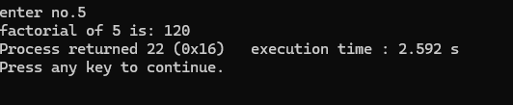

Q2) **Recursion program for fibonacci of a number**

#include<stdio.h>

int fib(int n)

{

if(n==1)

return 0;

else if(n==2)

return 1;

else

return(fib(n-1)+fib(n-2));

}

void main() {

int n;

printf("enter no.");

scanf("%d",&n);

printf("fibonacci of %d is: %d",n,fib(n));

}

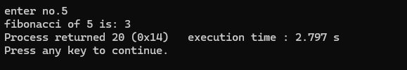

**Q3) Tower of Hanoi using recursion**

**#include<stdio.h>**

**void towerOfHanoi(int n, char source, char temp, char destination) {**

**if (n == 1) {**

**printf("Move disk 1 from %c to %c\n", source, destination);**

**return;**

**}**

**towerOfHanoi(n - 1, source, destination, temp);**

**printf("Move disk %d from %c to %c\n", n, source, destination);**

**towerOfHanoi(n - 1, temp,source,destination);**

**}**

**void main() {**

**int n;**

**printf("Enter the number of disks: ");**

**scanf("%d", &n);**

**towerOfHanoi(n, 'A', 'B', 'C');**

**}**

